**National University of Computing and Emerging Sciences-FAST**

**Project Report**

**Data Science**

**Group Members:**

**19K-1411 Muhammad Sajjad Aziz**

**19K-0297 Muhammad Bilal**

**19K-0263 Arman**

# Abstract:

Wanted to buy the same product you saw on someone but searching for the very same product using keywords can be a really big problem. What we wanted to develop is that the user can find his product on an ecommerce website by uploading a picture of it, if he does have a picture of product. When user uploads a picture of product, our trained models can provide the product details if available and if not he may have some similar products. And that is what drags us to do this project and by doing this project we got the deep knowledge of deep neural networks and image processing.

# Objectives:

What we wanted to achieve that the accuracy of similar images will be really good and the biggest constraint here was that the process of image classification and similarity must take few seconds, and Alhamdulillah we have achieved these objectives in our project.

# Introduction:

Having a picture of product and want to get the very same product, but searching for it can be a real problem. Searching keywords can make our process slightly less problematic but looking each and every product to find the very same or similar product can cause you go through many pages. For this purpose, we proposed image searching, you can upload the picture of the product you want and our model will provide you the very same product if available and some similar products.

# Methodology:

To accomplish our proposed solution, we will be implementing deep learning’s convolutional neural networks(CNN) for image classification and to find the similar images/products we will implement K-means and to transform the data we will use principal component analysis(PCA).

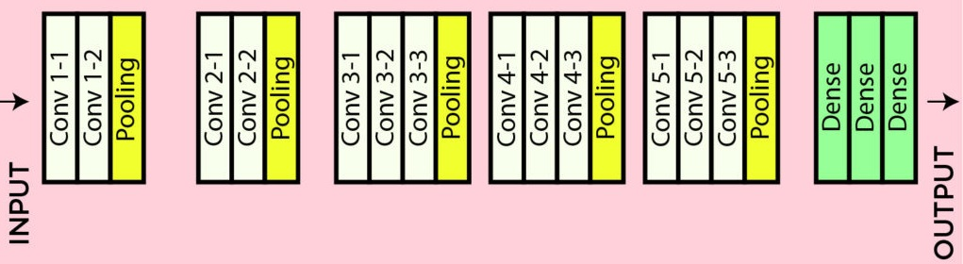

# Results:

When user upload an image of product, our CNN model will classify the image/product into a category in which it lies and then the similar products will be searched into that identified category by our K-means. In result, user will be having some products listing on screen from where he can select any product to buy.

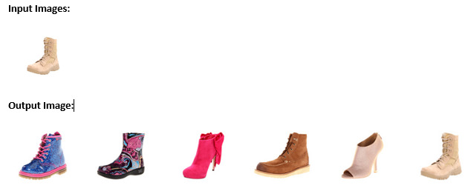

# Applications:

The project can be used as a service in any application for image searching might be an e-commerce application for searching products and similar products.

# Conclusion:

In conclusion, we developed an application for classifying images and to find similar images, for this purpose we implemented a CNN model and train it on shoes dataset, then we take the user input as an image, predict a class of image and lastly using K-means and PCA we find similar images to that image. It’s an application which can be used as a service where the user can search a product and in result he can get if this product is available and if not he will get some similar products from which he can by one.

# References:

[1] Debasish Kalita “Basics of CNN in Deep Learning.” Internet: <https://www.analyticsvidhya.com/blog/2022/03/basics-of-cnn-in-deep-learning/>, March 3, 2022 [April 23, 2022].

[2] Zakaria Jaadi “A Step-by-Step Explanation of PCA.” Internet: <https://builtin.com/data-science/step-step-explanation-principal-component-analysis>, December 1, 2021 [April 28, 2022].